UML DIAGRAMS TOURISM MANAGEMENT SYSTEMS

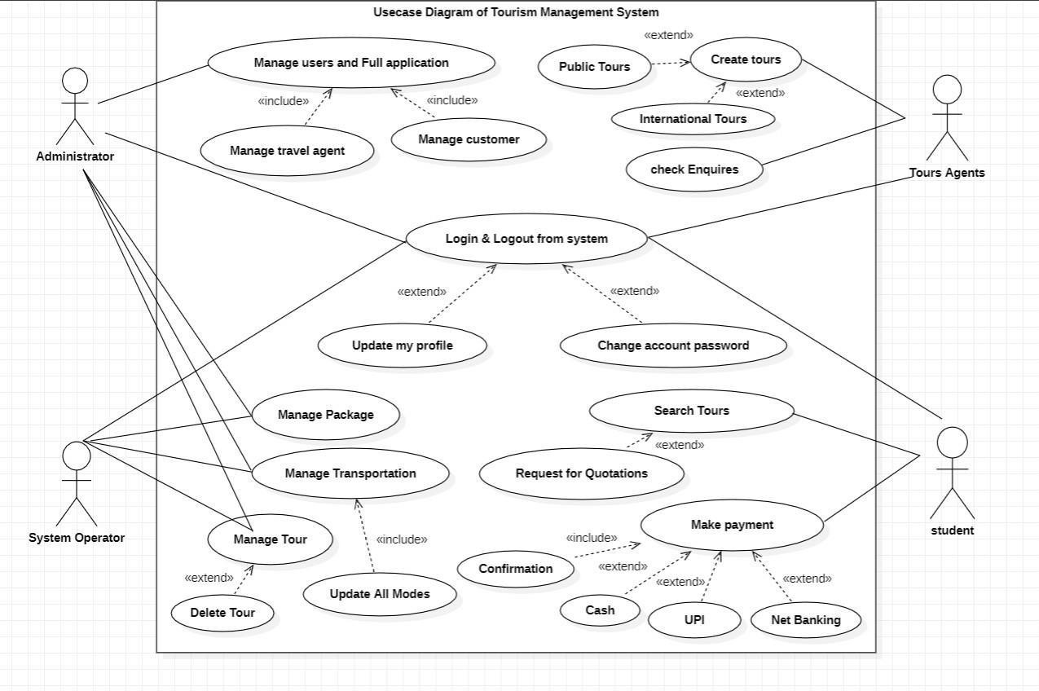

• ***Class diagram with explanation***

Activity diagram with explanation

***Activity diagram with swimlane***

